  Computer Science Practice Pathway | Project 2  ISCG6420 IWD  Semester 1, 2018 | 1
Create an Interactive Application.
Total Marks 100
Course Weighting 50%
Check Point 1: 30 April 2018
Check Point 2: 21 May 2018

Due: 8.30am on Monday,
June 4, 2018

Instructions

The project has three parts. All three parts should be presented as web sites on your dochyper space. Please don’t upload your work to the server before 10.30am 5 June 2018.
From 5 June 2017, your work must be placed on your dochyper space in the project2 folder, and linked to your existing homepage:

http://hyperdisc.unitec.ac.nz/iwd18s1/usernameIWD/project2

This project should be completed as a group work (only two students per group ) for Part 1 and Part 2. Part 3 is individual work. Students are reminded to read all pages related to assessment rules and academic integrity in Student Handbook. You are allowed to seek advice from any source, but your written submission must be your own work, except where clearly referenced.

Taupo Boat Adventure

Book Boat
Play Game
Cool Project Game
Content

Part 1 – Create online seat reservation system for Taupo Boat Adventure [40%]

Develop a small application for booking, using XML as external storage.
- Provide documentation for your application.
- Load boat layout settings from XML files. Users should be able to choose to book one of two different boat layout. Layout is outlined on the next page (page 2).
- Each boat layout must be populated dynamically on the page.
  - Some seats have already been taken, so users cannot book them.
  - Each seat price for first two rows is $30, for next three rows it is $25, and for the rest it is $20.
- Your program should calculate price for the booked seats.
- User should have clear information which seats he is booked, their cost; date and time of activity (riding a boat) and total cost.
- Your program should indicate that recently booked seats are not available any more.
- User can come back to book additional seats.

Rose Boat layout
 | 1 | 2 | 3 | 1 | 4 | 5 | 6
 | 7 | 8 | 9 | 2 | 10 | 11 | 12
13 | 14 | 15 | 16 | 3 | 17 | 18 | 19 | 20
 |  |  |  | 4 |  |  |  | 28
 |  |  |  | 5 |  |  |  | 36
 |  |  |  | 6 |  |  |  | 44
 |  |  |  | 7 |  |  |  | 52
 |  |  |  | 8 |  |  |  | 60
 |  |  |  | 9 |  |  | 66

Princess Boat layout

Part 2 – Create interactive game [40%]

Design a game for young children. The main character’s design and look is up to you. It can be a person, or an animal (It will be called Mr X for now). Mr X’s task is to catch and collect flying seeds. Seeds grow on plants between grass. Each seed will appear randomly on any plant branch as a small green ball (radius = 6px). Growing time for each seed is 4 seconds. Seeds grow up to size (radius=24px), and will gradually change colour from green to red during 4 seconds. Please use radial gradient in diagonal direction for the colour gradation. After that, the Seed will stay on the branch for 3 seconds and will fly away (up). Mr X will catch the seeds as they fly in his nettle. The flying time for each seed is 7 sec.

Mr X’s movement is controlled by using the keyboard arrow keys (up, down, left, right). Every time he successfully catches a seed, a positive score is added to his current score and a ‘happy’ sound is played. However, if a seed touch on Mr X’s body, an ‘unhappy’ sound will be played and his current score will be reduced by one. Mr X will be running in the middle of the stage (canvas) with a nettle. Each time he turns, the net comes around to the other side of Mr X.

The story board for the game is as follows:

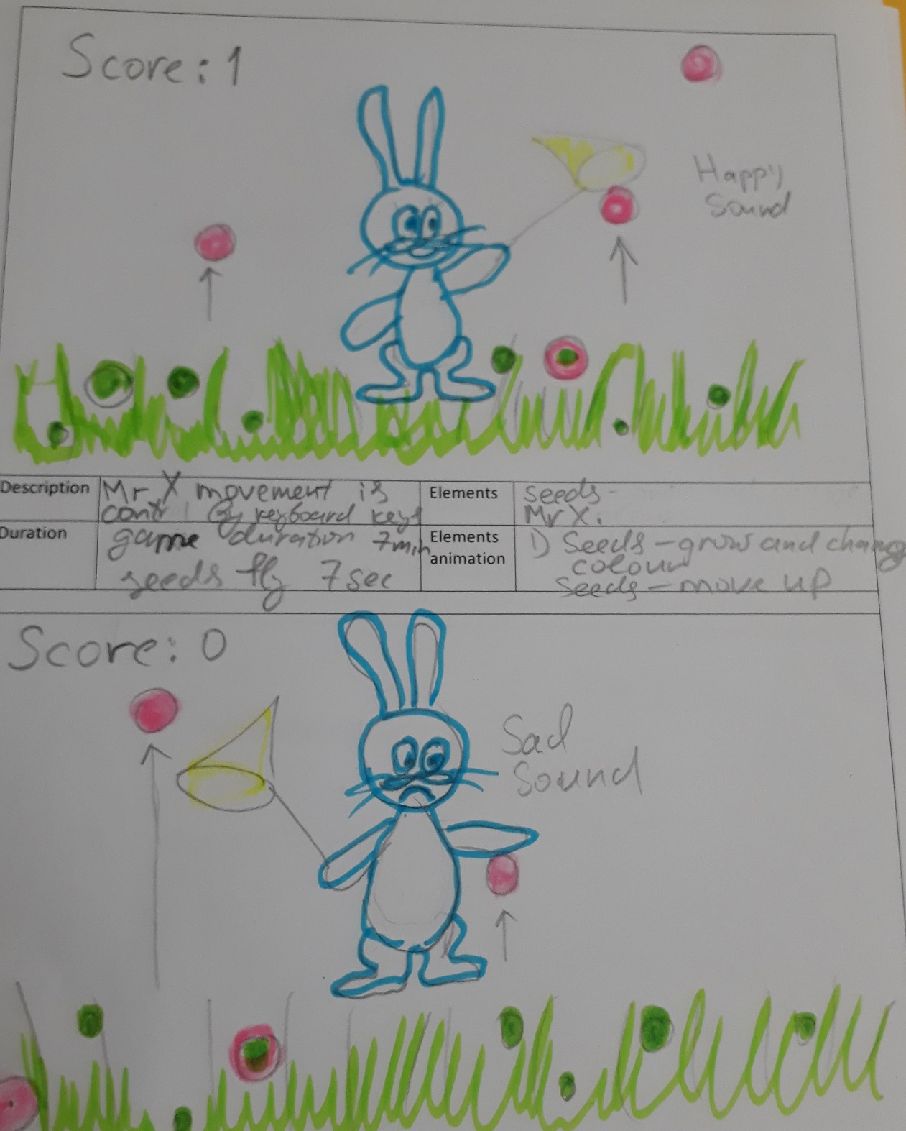

Additional criteria for the game:
- It should use (minimum 4) keyboard keys for user interaction (arrow keys).
- It should have 3 different sounds in the game (like two different collision beeps) and users should be able to control the volume of the sounds.
- Feedback needs to be provided for the users; for example, a mechanism to display the score and play sounds.
- It should have a time limit of 7 minutes, i.e. the game ends after 7 minutes.
- It has a start button to start/restart the game.

Part 3 – Individual Task 20%

You will need to write an application according to the task given by your tutor. You will do an individual presentation-defence for this task in the study week on a different day from group-presentation day. You will have to answer four technical questions during your defence time. Questions can be related to martials covered in the course, or explanation of your logical solution, or a task to write a code for particular functionality.

The grading for this component is weighted depending on how you performed in your homework tasks, 10% contribution to the course grade will be taken from the higher of these two assessment components. That is, if you have scored better in your homework than you have in this component, then the grade from you home work will be used. If you scored poorly in your homework, then good performance in this component will allow you to improve your overall grade for this course.

Marking Guide
Marks for your work will be given according to the following marking schedule:
Item No. | Item | Marks
 | Part 1
 | XML file with proper data. Ability to read from XML and create a boat design layout on web page,  Display desired Boat layout requested by user. (seat /row numbers, cost for each seat, booking yes/no) | 20
 | Booking, correct calculation for the tickets cost. Booked seats become not available after booking is paid for. | 20
 | Part 2
 | Overall design and complexity of scenery (background) and overall design and complexity of play character - Mr X | 5
 | The play’s character - Mr X animation(turnoff basket, eye movements) | 4
 | Growing seeds animation (changing size animation) Changing seeds’ colours ( radiant) animation, Seeds move up animation | 5
 | Collision detection. Sound in the game collision beep – “happy sound” and “unhappy sound”. Scores displayed correctly. | 20
 | The game should have time restriction of 7 minutes  Use 4 keyboard arrow keys (up, down, left, right) for user interaction | 3
 | Other Sounds at the beginning of the game and at the end of the game.  User can control volume | 3
 | Part 3
 | An implementation of specific requirements, given as individual task by your lecturer. | 12
 | Individual Presentation / Defence, Answers to questions (4) | 8
 | Note: Grade for Part 3 will be higher of the two: grade from this component, or the grade received from the homework tasks.
 | Check Point 1: Complete ( Part 1 – 1 for one boat, Part 2 -1, 2)
 | Check Point 2: Complete ( Part 1 – 1 for two boat, Part 2 -2, 3 and All Documentation on World Press Website )
 | Group Presentation (if you miss -10 marks will be deducted from your individual grade)
 | Total marks | 100
 | Documentation (up to 20% deduction if you don’t have it)
1 Complete as WordPress website
2 XML data design
3 User booking design page
4 Your own game storyboard
5 Testing (Test Cases)

Details

Possible sources of information
You can use resources such as academic journals, web sites and other Internet sources, class discussions and handouts, journals, newspapers and magazines, books, CD-ROMs and businesses’ promotional literature. You need to provide the references of all the sources of information that you use. When referencing web sites, you should, where possible, give the author, title and date of the resources, and the full URL of the page(s) referred to, rather than just the address of the home page.

Delivery
- Your work as a web site is due by 8.30am on Monday, June4, 2018.
- A softcopy of your web site must be uploaded on Moodle using Project two submission link before the deadline. Please use a zip file, it should have a name project2_FirstStudentName_ID_ SecondStudentName_ID
- Your web site must be uploaded on dochyper after 2 days only.
- One page as a standard cover sheet as a softcopy should be included in your zip folder as well (please download cover page from Moodle). This page must include a signed declaration that “this submission is my own work, except where clearly referenced”.
- A copy of your submission will be kept by Computer Science Practice Pathway for future reference and audit purposes.

Rules for Late Submission of Assignments
a. The due dates of assessment work will be notified in course information.
b. Assignments submitted after the due date and time without having received an extension through Special Assessment Circumstances (SAC) will be penalised according to the following:
• 10% of marks deducted if submitted within 24hrs of the deadline
• 20% of marks deducted if submitted after 24hrs and up to 48hrs of the deadline
• 30% of marks deducted if submitted after 48hrs and up to 72hrs of the deadline
• No grade will be awarded for an assignment that is submitted later than 72hrs after the deadline.

c. Students submitting assignments after the due date and time will be ineligible to resubmit a failed assignment.

Special Assessment Circumstances – Process
1)
In the first instance, the Student shall complete the approved form to apply for consideration of affected performance and submit the application to Student Central. Except in exceptional circumstances this must be no later than 5 working days after the due date of the Summative Assessment, and with appropriate documentary evidence of both the circumstances and the effect on performance. Except in exceptional circumstances appropriate documentary evidence such as a medical certificate must be dated within 24 hours or one working day of the due time of that Assessment item.

https://ds.unitec.ac.nz/dsweb/Get/Document-632
Plagiarism
Plagiarism will be reported to the Academic Leader who may award zero marks.

Do you want to do the best that you can do on this assignment and improve your grades?
You could:
• Talk it over with your lecturer
• Visit Te Tari Awhina or Maia for learning advice and support
• Visit the Centre for Pacific Development and Support
• Contact the USU Advocate for independent advice
• For contact details and more information, go to www.usu.co.nz

